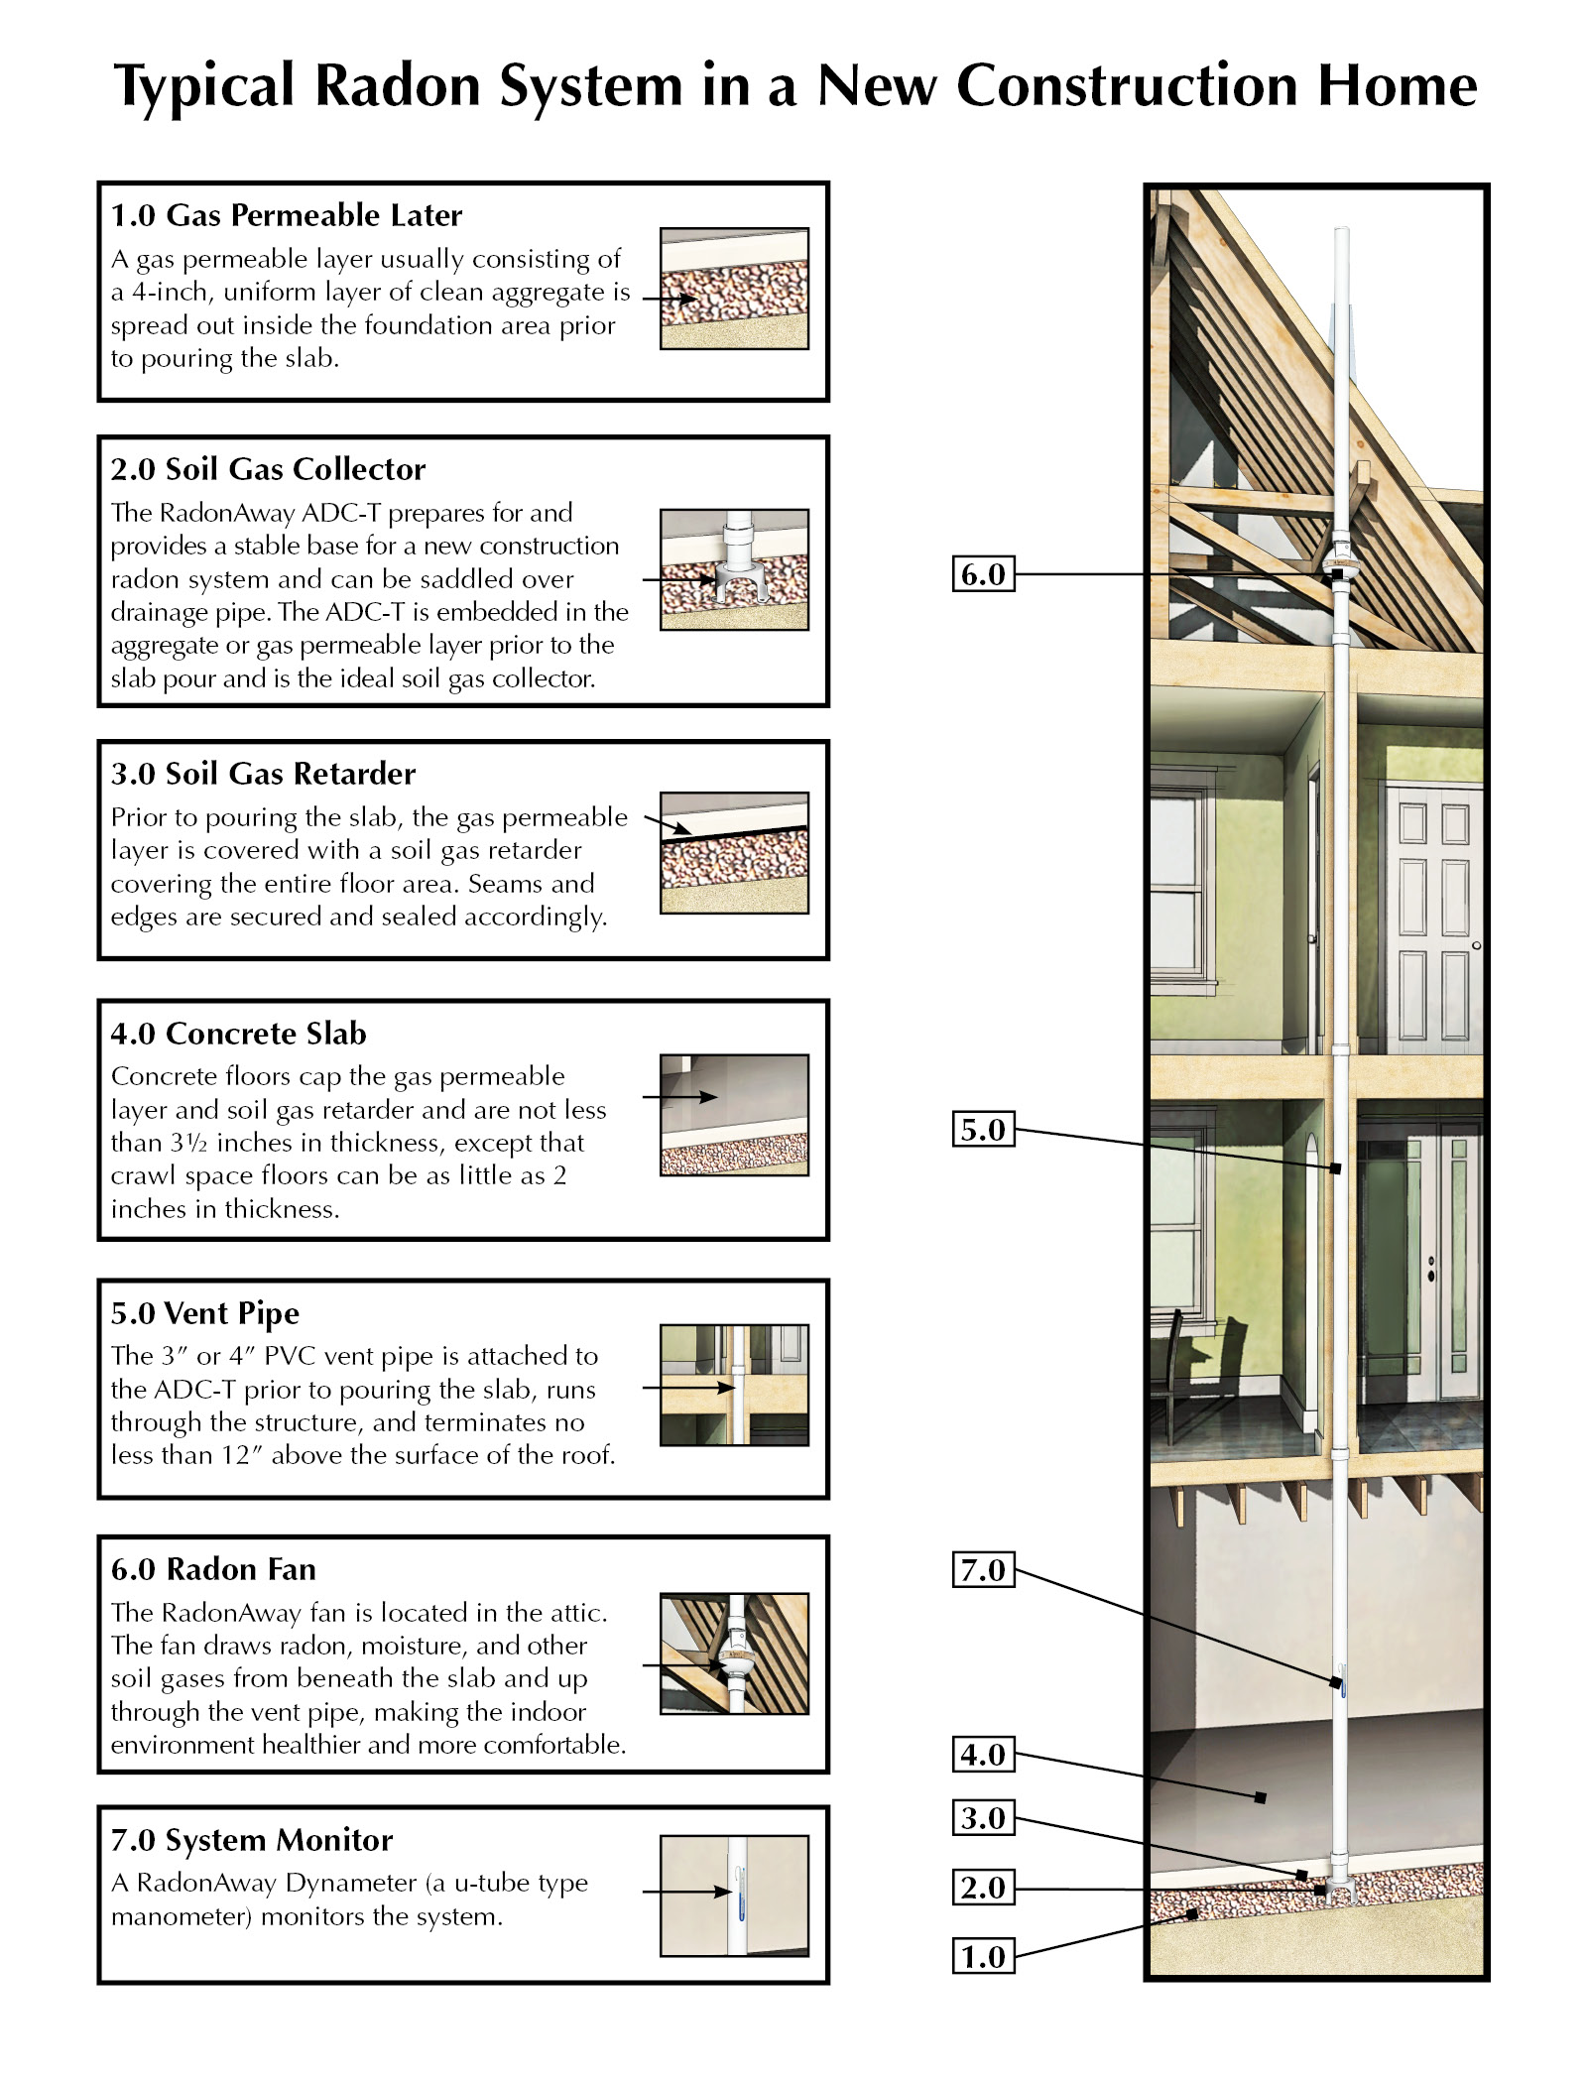
1.0 Gas permeable layer. A gas permeable layer shall be installed in accordance with Section 1.1, 1.2 or 1.3.
1.1 Gravel. A uniform layer of clean aggregate, not less than 4 inches in depth, shall be placed over the soil. The aggregate shall have a void ratio of not less than 35 percent or shall be in accordance with Size Number 4, 5, 56, or 6 as classified by ASTM C33.
1.2 Geotextile. A layer of geotextile drainage matting shall be placed over a uniform layer of either native or fill sand. The geotextile drainage matting shall be designed to allow the lateral flow of soil gasses to the system’s suction point fitting. The geotextile matting shall have a cross-sectional area of not less than 12 square inches and shall be placed, at a minimum, along the entire inside perimeter of the foundation within 18 inches of the footing.
1.3 Pipe loop. A loop of 3 or 4 inch nominal diameter perforated pipe shall be placed along the entire inside perimeter of the foundation within 18 inches of the foundation walls. Such piping shall be placed in a trench backfilled with clean aggregate meeting the criteria of Section 1.1 such that the pipe is completely surrounded by not less than 4 inches of aggregate.

2.0 Soil Gas Collector. One suction point shall be provided for each 1,600 square feet of floor area or portion thereof. Not less than one suction point shall be provided for each foundation type. Multiple suction points required for areas in excess of 1600 square feet shall be distributed throughout the floor area so as to provide Active Soil Depressurization (ASD) coverage across the entire floor area. Suction points shall be installed in accordance with Sections 2.1, 2.2 or 2.3 as applicable for the type of gas permeable layer installed.
2.1 Gravel layer system. A suction point for a gravel type gas permeable layer system shall consist of a RadonAway ADC-T pipe fitting or other device having not less than two openings oriented so as to create multiple horizontal intake openings within the gravel layer. The horizontal openings shall be provided with not less than 24 inches of perforated pipe extending from the fitting or device into the gravel layer. Suction point openings above the slab shall be protected from the entry of aggregate, concrete and debris.
2.2 Geotextile layer system. A suction point for a geotextile gas permeable layer system shall consist of a RadonAway ADC-T pipe fitting or other device having not less than two openings oriented so as to create multiple horizontal intake openings communicating with the geotextile mat. Suction point openings above the slab shall be protected from the entry of aggregate, concrete and debris.
2.3 Pipe loop system. A suction point for a pipe loop system shall consist of a RadonAway ADC-T pipe tee fitting or pipe saddle device installed in the loop piping. Suction point openings above the slab shall be protected from the entry of aggregate, concrete and debris.

3.0 Soil gas retarder. The gas permeable layer shall be covered with a soil gas retarder installed in accordance with the following:
3.1 Sheeting. Polyethylene sheeting of not less than 6 mils in thickness or cross-laminated polyethylene sheeting of not less than 3 mils in thickness shall be installed on top of the gas permeable layer and shall completely cover the layer. Where sheet foam board insulation is installed on top of the gas permeable layer, the polyethylene sheeting shall be installed on top of the foam board insulation.
3.2 Seams. Seams between adjacent polyethylene sheets shall be overlapped not less than 12 inches.
3.3 Repairs. Tears or punctures in the polyethylene sheeting shall be closed in a gas-tight manner or an additional sheet of polyethylene shall cover the tear or puncture with an overlap of not less than 12 inches on all sides. Such additional sheet shall be fixed in place to prevent displacement during slab casting.
4.0 Concrete slab. Concrete floors shall be not less than 3½ inches in thickness except that crawl space floors shall be not less than 2 inches in thickness.
4.1 Penetrations. Slab openings and penetrations of concrete floors shall be sealed gas-tight.
4.2 Interior footings. Where interior footings divide a gas permeable layer into two or more areas, the areas shall be joined together in accordance with Section 4.3 or shall be considered as separate areas each provided with the required suction points.
4.3 Joining areas. Gas permeable areas shall be joined by the installation of not less than two 4 inch pipes installed through the interior footings. There shall be not less than one 4 inch pipe sleeve for every 20 feet of footing length.

5.0 Piping. The ASD system piping shall be in accordance with the following sections:

5.1 Pipe size. All ASD system pipe shall be not less than 3 inch nominal inside diameter.
5.2 PVC piping. PVC pipe shall comply with ASTM D2665, F891, or F1488. The pipe wall thickness shall be the same as Schedule 40 PVC pipe.
5.3 Slope. Above ground piping shall have a slope of not less than 1/4 inch per foot. Piping shall slope downwards towards the suction point. Piping arrangements that could allow water to collect are prohibited.
5.4 PVC plastic pipe joints. The joint surfaces for PVC plastic pipe and fittings to be solvent welded shall be prepared with a purple primer conforming to ASTM F 656. PVC plastic pipe joints shall be solvent welded in accordance with the pipe manufacturer’s instructions with solvent cement conforming to ASTM D 2564. Where disassembly of piping is required such as for removal of a fan, the joints shall be made with flexible unshielded couplings complying with ASTM D5926 or ASTM C1173 or equivalent method.
5.5 Support. Above ground piping shall be supported by the structure of the building using hangers or strapping designed for piping support. Supports for horizontal piping shall be installed at intervals not exceeding 4 feet and supports for vertical piping shall be installed at intervals not exceeding 10 feet.
5.6 Protection against physical damage. Where pipes penetrate top or bottom plates of stud walls and the nearest edge of the hole is within 1 ½ inches of the face of the member, the pipe shall be protected by steel shield plates. Such shield plates shall have a thickness of not less than 0.0575 inches (1.463 mm) (No. 16 gage). Such plates shall cover the area of the pipe where the plate is bored, and shall extend not less than 2 inches above bottom plates and below top plates.

6.0 Radon Fan. Fan to be an Energy Star rated RadonAway RP140 (basements under 1,500 sq. ft. with 4” vent pipe), a RadonAway RP145 (basements under 2,000 sq. ft. with 3” or 4” vent pipe), or an Energy Star rated RadonAway RP260 (basements over 2,000 sq. ft. with 4” vent pipe and for combination foundation types). Attach fan to vent stack w/flexible PVC couplings and stainless steel clamps above and below. Couplings to be Pipeconx PCX56-44 (RP140 and RP145) or PCX06-44 (RP260) or approved alternate. Mount fan such that lower fan coupling is 3” minimum above top level of insulation.

6.1 Electrical. Provide 110V wiring box on a dedicated circuit above attic insulation within 4 feet of the fan location (properly label circuit on system label).
7.0 System Monitor System monitor to be u-tube type RadonAway Dynameter (pressures from 0 to 4” WC with non-toxic fluid).

8.0 Sealing. Penetrations through the concrete slab and soil gas retarder shall be sealed with a caulk complying with ASTM C920 class 25 or higher, or equivalent method.
8.1 Seal floor to foundation wall. The intersection of floors and foundation walls shall be sealed with a caulk complying with ASTM C920 class 25.
9.0 Labeling. Label piping on each floor level and in the attic, visible from accessible locations along pipe route. Provide a radon reduction system label adjacent to the pressure monitor.

